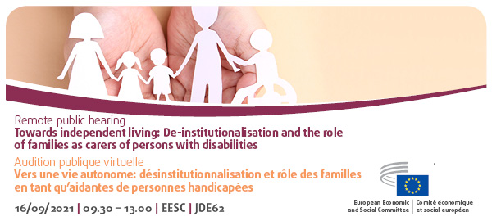

Agenda

9:00 – 09:30 | Testing connections
09:30-09:40 | Introduction by  - Pietro Barbieri, President of the EESC Thematic Study Group
09:40-11:30 | Panel 1:  Moderator: Marie Zvolska, TSG DIS Member  Interventions by  - Saša Mlakar, Secretary for coordination of international affairs for PWD, Slovenian Presidency  - Inmaculada Placencia Porrero, DG EMPL C3 (Disability and Inclusion), European Commission  - Jose Gusmao, Disability Intergroup, European Parliament  - Robert Jan Uhl, Fundamental Rights Agency (FRA)  - Carlo Giacobini, Director of Esplicando Disabilita  - Luc Zederloo, European Association of Service Providers for Persons with Disabilities (EASPD)  Q&A
11:30 – 11:45 | Break
11:45 – 12: 55 | Panel 2:  Moderator: Hana Popelková, TSG DIS Member  Interventions by:  - Testimonial by Petr Lanik, a young person with disabilities who transitioned from an institution to the community in Czech Republic  - Elena Improta, caregiver and Director, Association "Oltre lo sguardo" ONLUS  - Catherine Naughton, Director, European Disability Forum (EDF)  - Camille Roux, COFACE Families Europe  - Ines Bulic, European Network for Independent Living (ENIL)  - Milan Šveřepa, Inclusion Europe  Q&A
12:55–13:00 | Closing remarks by  - Pietro Barbieri, President of the Thematic Study Group on Disability Rights

Participants can speak FR/EN/IT/DA/PT/CS/PL/SK/LT/RO and listen to FR/EN/IT/PL

